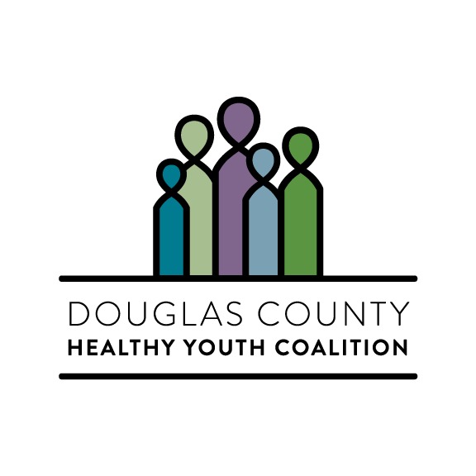 | MEETING AGENDA  Douglas County Healthy Youth Coalition  Virtual Meeting - Google Hangouts  November 11th, 2020 – 5:00 pm-7:00 pm
TOPIC |  | PRESENTER | TIME
Welcome / Introductions  - Welcome  - Introductions  - Approve October Meeting Minutes |  | All / Curtis | 10 min
Updates  - Leadership team is still making progress on bylaws– special thanks to Cathy Dunwoody  - DCHYC Parenting Newsletter will be released on the evening of November 13th. leadership team please review draft articles, please contact me ASAP if you have any issues with content or resources -  - Welcome new members: Angela Frank, Andi Houdek, Audra Bryne, Jason Strong, and Kristen Rupprecht & Veronic Nobles with (Noble One)  - Douglas County Mental Health Initiative still needs our assistance with providing (youth) feedback on their Mental Health Toolkit – Link  - Coordinator met with DCSD and TCHD fiscal agent team to determined that DCHYC has approximately 45k in unobligated grant funds from FY19/20. Coalition and submit a request to SAMHSA to carryover these funds into the FY20/21  - Colorado National Guard informed us that they have received leadership approval to purchase a trailer for our future awareness events  - Coordinator recently learned that grant funding can be used to pay for 501c3 application fees and contracted services to provide legal review of key organizational guiding documents (bylaws) |  | Leadership Team | 10 min
Committee/Taskforce Updates  - Youth Leader Board (Laura, Liza, Jordan)  - Restorative Justice/Practice  - Equity & Inclusion (Equity Growth Zone)  - Data & Evaluation (community assessment)  - E-cigarette/Vaping |  | Committee Members | 10 min
Colorado Healthy Kids Survey Presentation - (Douglas County Data), Colorado School of Public Health - Presentation link |  | Alicia Bowyer | 60 min
Regional Teen Institute Presentation – Prevention+Ed |  | Kristin Bengtson | 15 min
New Business/Open discussion  - New leadership team decision item  - Use FY19/20 carry over funding to purchase Colorado Teen Institute curriculum ($3,500)  - Use FY19/20 carry over funds to create four two-page visual infographic awareness documents, using local data sources. Documents and information assembled by vendor will help the coalition and our stakeholders educate the community about issues our young people are facing, as well as protective factors that can buffer against these issues; Vaping/Tobacco, Alcohol, Marijuana/THC & Mental Healthy ($12,000).  - Use FY19/20 carry over funds to lease 10x10 indoor storage facility, to store coalition equipment and other miscellaneous materials (approximately $1,300)  - Coordinator would like to seek leadership team approval to permit the communications team to allow newsletter contributors to promote their services, as long as these services are in alignment with our Vision, Mission, Goals, and are science based  - Using FY19/20 Carry over Funds the Coordinator would like to allocate $2500 towards Community Anti-Drug Coalitions of America, National Leadership Forum registrations for, four coalition members to attend virtually February 1-4 2021  - Coordinator would like to obtain coalition leadership team approval to use FY19/20 Carry over Funds to pay for the update/reprint of our Pocket Resource Guide. We are looking to print 4200 copies at a total cost of $3500  - Coordinator will also be requesting an additional $3000 dollars to contract with Hispanidad to translate these materials into Spanish, as well as connect with LatinX community “influencers”  - Discuss potential newsletter articles for December, obtain volunteers contributors |  | Members | 15min
Next Meeting / Next Steps  - Questions Concerns |  | Curtis/Members | 15 min

Next Coalition meeting(s):

Leadership Strategic Planning Meeting - December 9th 2020 - (In-Person/Zoom meeting)

Regular Monthly Meeting January 13, 2020 - Time: 5:00pm – 7:00pm (Zoom Meeting)

Updates/announcements/resources

Colorado Helathy Kids Survey Data - Link

Changes in Adult Alcohol Use and Consequences During the COVID-19 Pandemic in the US - Link
Recently published in the Journal of the American Medical Association examined changes in adult alcohol use during the COVID-19 pandemic. Data on drinking patterns from 2019 was compared against data collected from May 28to June 16, 2020, several months after the pandemic began. Researchers found that the frequency of alcohol consumption increased by 14% overall, 17% for women, 19% for adults age 30 to 59 years, and 10% for non-Hispanic white individuals. The study also noted a significant increase in heavy drinking among women, rising 41% since 2019

Douglas County Mental Health Initiative survey - Link

Mental Wellness Basics, Preparing Students for Wellness & Mental Health Education (Students & Teachers k-12) – Link

Resources:

Forward Together was created to help you build and strengthen your relationship with the young people in your life through their growing and developing years. Link

COVID-19 Resources for Parents – Link

Activity’s for family’s at home - Link

Academic support for families - Link

Colorado Department of Education, Resources for learning at home - Link

Remote learning resources – Link

Talk. They Hear You - SAMHSA’s substance use prevention campaign helps parents and caregivers start talking to their children early about the dangers of alcohol and other drugs. Link

Operation Prevention, The Science of Addiction- The Stories of Teens Link
Educator lessons Link

Twelve Talks to Have with Teens (Jefferson County Communities the Care) - Link

The Distance Learning Playbook for Parents Rosalind Wiseman - Link

The Distance Learning Playbook for College & University Instruction with Douglas Fisher - Link

Christmas Tree Initiative:

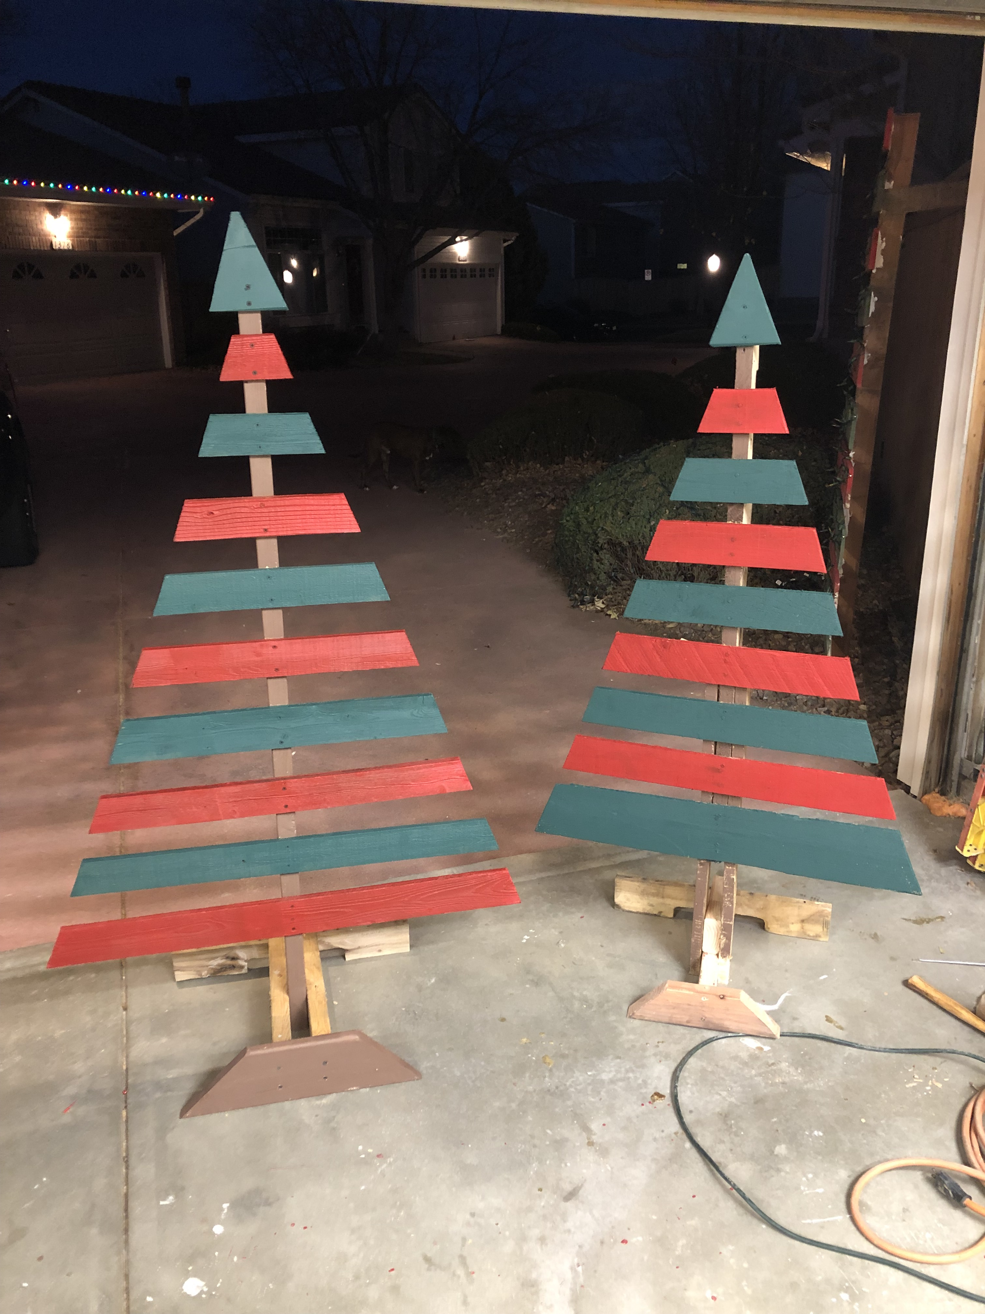

Nara Altman is unable to attend tonight’s meeting, she is currently under the care of medical professionals. Her husband informed me last night that she is well and resting and will return home this weekend. Nara’s husband received a hot Crockpot full of White Chicken Chili and tortillas, as well as well wishes from the Coalitions Leadership Team

Angie Frank is a board-certified pharmacologist (PharmD, BCPS). She is interested in joining the Douglas County Youth Coalition and its leadership team because she has 3 kids in the district and works closely with drug diversion within her hospital. She is an Advanced Clinical Specialist Pharmacist at a Denver HealthOne hospital. She analyzes statistical comparisons to postulate if there is an employee diverting medications. Additionally, she has volunteered for the Ranch View Middle School SAC for 3 years and she is currently on the Thunder Ridge High School SAC, and Colorado's State Advisory Committee for Parent Involvement and Engagement. She also helps with the sacrament of Confirmation at her church.

Audra Byrne has been an educational advocate in the Douglas County School District since her oldest daughter started 1st grade in 2009. Now with two daughters in high school and son in 3rd grade, she continues to actively support youth in her community. Audra graduated from Arizona State University with a BA in Elementary Education and attained a master’s in Educational Leadership from the University of Northern Colorado. As a former educator and administrator for Cherry Creek Schools, Audra’s passion runs deep for public education. As a mother watching her own children navigate school today, she’s invested in coaching youth to advocate for their academic and social-emotional success. Additionally, with two of her children identified as gifted learners, she has a front row seat to the mental health issues that run rampant in the gifted student. Audra has held multiple volunteer leadership positions in DCSD such as School Accountability Chair and most recently the Ponderosa Feeder Parent Liaison on the Douglas County Gifted Education Accountability Committee.

